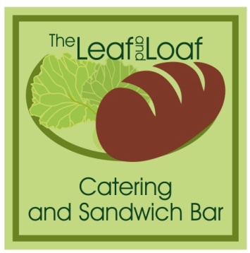
Afternoon Tea Buffet £12.00 per head

A selection of sandwiches on white and brown bread:
Cream cheese and cucumber, Egg mayo and cress, Ham and tomato, Tuna mayo.
...........................................................................................................................
Freshly baked sausage rolls
Crisps
Salad
..........................................................................................................................
Homemade Scones with Clotted cream and Jam
..........................................................................................................................
Homemade Brownie
Homemade Lemon Drizzle

Delivery and extras.

Buffets are a minimum of 6 people. Plates and napkins are not included but can be added for an extra charge.
A charge will incur for lost or damaged serving plates.

Should you wish to make a booking or discuss our menus further, please do not hesitate to contact Sharon Davison at The Leaf and Loaf. All buffets can be tailored to suit your personal requirements.
All dietary requirements can be catered for. Please ask for more details.

01773 740222 / 07949335864 theleafandloaf100@gmail.com www.theleafandloaf.uk

